

ARCHITECTURE DESIGN ASSIGNMENT
CYBERSHILD 360:AI-BASED ENTERPRISE CYBERSECURITY MONITORING AND THREAT INTELLIGENCE SYSTEM
CSA1016-SOFTWARE ENGINEERING
Name : J.C.Hemalatha
Reg.No:192573015
Department: CSE(DS)

1. Analyze System Requirements
1.1 System Objectives
Modern enterprises generate large amounts of security data from computers, servers, network devices, applications, cloud services, and security tools. Detecting cyber threats manually can be time-consuming and may result in delayed responses.
CYBERSHIELD 360 is an AI-based enterprise cybersecurity monitoring and threat intelligence system designed to continuously monitor enterprise security activities, detect suspicious behavior, analyze cyber threats, and provide alerts to security administrators.
The system collects security events from multiple sources such as firewalls, servers, endpoints, network devices, and applications. AI-based analysis is used to identify abnormal patterns and potential cyber threats. Threat intelligence data is used to enrich detected events and determine the severity of threats.
The system provides a centralized security dashboard where administrators and security analysts can monitor alerts, investigate incidents, view threat intelligence, and generate security reports.
Objectives
- Continuously monitor enterprise security events.
- Detect suspicious and abnormal activities.
- Identify potential cyber threats using AI.
- Analyze and classify detected security incidents.
- Integrate threat intelligence information.
- Generate real-time security alerts.
- Provide a centralized security monitoring dashboard.
- Help security teams investigate and respond to incidents.
- Generate security reports and analytics.
- Improve enterprise cybersecurity visibility.

1.2 Functional Requirements
User Authentication
The system allows security administrators and analysts to securely log in and access the system according to their assigned roles.
Security Data Collection
The system collects security events from:
- Firewalls
- Servers
- Endpoints
- Routers and switches
- Applications
- Cloud services
- Network monitoring tools
Real-Time Monitoring
The system continuously monitors incoming security events and displays important activities on the security dashboard.
Threat Detection
The system analyzes security events to identify suspicious activities such as abnormal login attempts, unusual network traffic, and unauthorized access.
AI-Based Threat Analysis
AI/ML models analyze security event patterns and identify anomalies or potentially malicious behavior.
Threat Intelligence
The system compares detected indicators with threat intelligence information to identify known malicious IP addresses, domains, URLs, or other indicators.
Risk Classification
Detected threats are classified according to their severity, such as:
- Low
- Medium
- High
- Critical
Security Alerts
The system generates alerts when suspicious or malicious activities are detected.
Incident Management
Security analysts can investigate, classify, update, and track detected security incidents.
Security Dashboard
The dashboard displays:
- Active threats
- Security alerts
- Threat severity
- Attack patterns
- Incident statistics
- Threat intelligence information
Report Generation
The system generates reports related to security incidents, detected threats, alerts, and system activity.

1.3 Non-Functional Requirements
Performance
The system should process large numbers of security events with minimum delay and provide rapid threat detection.
Scalability
The architecture should support increasing numbers of users, devices, security events, and enterprise data sources.
Security
Sensitive security information must be protected using authentication, authorization, encryption, and secure communication.
Reliability
The system should reliably collect and analyze security events without losing important security information.
Availability
The monitoring system should remain available continuously because cybersecurity monitoring requires 24×7 operation.
Maintainability
The system should have modular components so that individual services can be updated or maintained independently.
Usability
The dashboard should be simple and easy for security administrators and analysts to understand.
Data Privacy
Security logs and enterprise information should be protected from unauthorized access.

1.4 Quality Attributes
Quality Attribute | Description
Scalability | Supports increasing security events, devices, and users.
Performance | Processes security events and generates alerts with low latency.
Security | Protects enterprise security data using authentication and encryption.
Reliability | Provides dependable monitoring and threat detection.
Availability | Supports continuous 24×7 security monitoring.
Maintainability | Modular components simplify updates and debugging.
Accuracy | AI-based analysis helps reduce incorrect threat identification.
Interoperability | Can integrate with enterprise security tools and data sources.

2. Selected Software Architecture
Microservices-Based Architecture
For CYBERSHIELD 360, a Microservices Architecture is suitable because the system contains several independent cybersecurity functions such as data collection, threat detection, AI analysis, threat intelligence, alert management, and reporting.
Each major function can operate as an independent service while communicating through APIs or event-based communication.
Major Services
- User Authentication Service
- Security Data Collection Service
- Event Processing Service
- AI Threat Detection Service
- Threat Intelligence Service
- Risk Analysis Service
- Alert Management Service
- Incident Management Service
- Reporting Service
- Dashboard Service
- Database/Storage Service
Justification
Microservices architecture is suitable because cybersecurity systems continuously receive large volumes of security events. Individual services can be scaled according to their workload.
For example, if the event-processing workload increases, the event-processing service can be scaled without modifying the dashboard or reporting service.
It also improves maintainability because individual services can be developed, tested, updated, and deployed independently.

3. Software Architecture Diagram
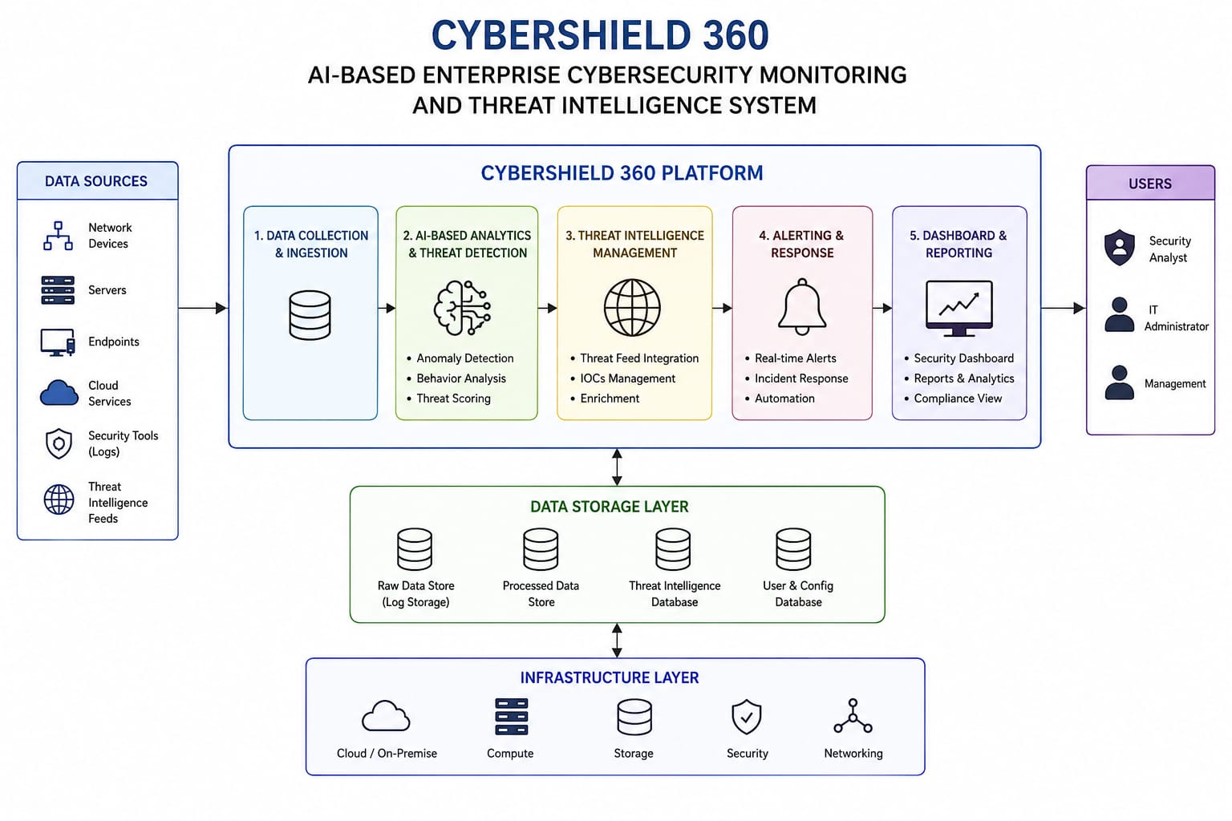

4. Components and Their Interactions
4.1 Security Data Collection Service
Collects security events from enterprise sources such as firewalls, servers, endpoints, applications, and network devices.
Function:
Receives and forwards security logs to the event-processing service.

4.2 Event Processing Service
Processes incoming security events by filtering, normalizing, and correlating the collected data.
Function:
- Removes unnecessary data.
- Converts different log formats into a common format.
- Groups related security events.
- Sends processed events for AI analysis.

4.3 AI Threat Detection Service
Uses AI/ML techniques to analyze security events and identify abnormal patterns.
Function:
- Detects unusual behavior.
- Identifies suspicious activities.
- Detects possible cyber attacks.
- Assigns detection scores.

4.4 Threat Intelligence Service
Provides additional information about detected threats.
Function:
- Checks suspicious IP addresses.
- Checks suspicious domains.
- Checks URLs or other indicators.
- Provides known threat information.

4.5 Risk Analysis Service
Analyzes detected threats and determines their severity.
Example:
Normal Activity → Low Risk
Suspicious Activity → Medium Risk
Confirmed Threat → High Risk
Critical Attack → Critical Risk

4.6 Alert Management Service
Generates real-time alerts when threats are identified.
Security administrators can receive alerts through the monitoring dashboard.

4.7 Incident Management Service
Allows security analysts to investigate detected incidents and track their status.
Example statuses:
New → Investigating → Resolved

4.8 Security Dashboard
Provides a centralized interface for administrators and security analysts.
It displays:
- Threat alerts
- Threat severity
- Security events
- Active incidents
- Threat statistics
- AI detection results

4.9 Reporting Service
Generates security reports for administrators.
Reports may include:
- Daily security incidents
- Detected threats
- High-risk events
- Attack statistics
- Alert statistics
- Incident resolution reports

4.10 Database and Log Storage
Stores:
- Security events
- User information
Threat intelligence
- AI analysis results
- Alerts
- Incident records
- Security reports

4.11 Overall System Workflow
Enterprise Devices
↓
Security Data Collection
↓
Event Processing
↓
AI Threat Detection
↓
Threat Intelligence Analysis
↓
Risk Classification
↓
Threat Detected?
↙ ↘
NO YES
↓ ↓
Store Data Generate Alert
↓
Incident Investigation
↓
Security Dashboard
↓
Report Generation

5. Quality Attributes
Scalability
Microservices allow individual services to be scaled independently when the number of security events or enterprise devices increases.
Security
The system protects sensitive cybersecurity information using authentication, authorization, encryption, and secure API communication.
Performance
Event processing and AI analysis are separated into independent services, allowing security events to be processed efficiently.
Reliability
Independent services reduce the impact of individual component failures. Security data can also be stored for later analysis.
Maintainability
Each cybersecurity function is separated into its own service. Developers can modify one service without redesigning the complete system.
Availability
The system can support continuous security monitoring by deploying important services with redundancy and backup mechanisms.
Accuracy
AI-based threat analysis combined with threat intelligence helps identify suspicious activities and improve threat classification.

6. Architectural Decisions
6.1 Rationale
Microservices architecture was selected because CYBERSHIELD 360 consists of multiple independent cybersecurity functions. Separating these functions improves scalability, maintainability, deployment flexibility, and system integration.
The architecture also makes it easier to integrate future AI models, new threat intelligence sources, and additional enterprise security tools.

6.2 Advantages
- Highly modular architecture
- Independent service deployment
- Better scalability
- Easier maintenance
- Supports AI integration
- Supports real-time monitoring
- Easy integration with external security tools
- Improved fault isolation
- Supports future expansion
6.3 Disadvantages / Trade-Offs
- More complex than a simple monolithic architecture.
- Communication between services can introduce latency.
- Requires monitoring of multiple services.
- Deployment and management can require additional infrastructure.
- Security must be maintained across service-to-service communication.

6.4 Future Enhancements
Future versions of CYBERSHIELD 360 can include:
- Advanced deep-learning threat detection.
- Automated incident response.
- Zero-trust security integration.
- AI-powered attack prediction.
- Security orchestration and automated response.
- Cloud security monitoring.
- IoT security monitoring.
- User and Entity Behavior Analytics (UEBA).
- Automated threat hunting.
- Security chatbot for analysts.
- Real-time attack visualization.
- Multi-cloud threat monitoring.

Final Architecture Summary
CYBERSHIELD 360 uses a Microservices Architecture in which enterprise security data is collected, processed, analyzed using AI, enriched with threat intelligence, classified according to risk, and presented through a centralized security dashboard.
The architecture supports the important requirements of the system—scalability, security, performance, reliability, availability, maintainability, and interoperability—which are the same quality-attribute categories emphasized in your assignment rubric.
This structure should fit your 25-mark Architecture Design Assignment very well because the rubric separately evaluates requirements analysis, architecture selection, architecture diagram/component design, quality attributes, and architectural justification.

